PostgreSQL
Launch ‘pgadmin 4’
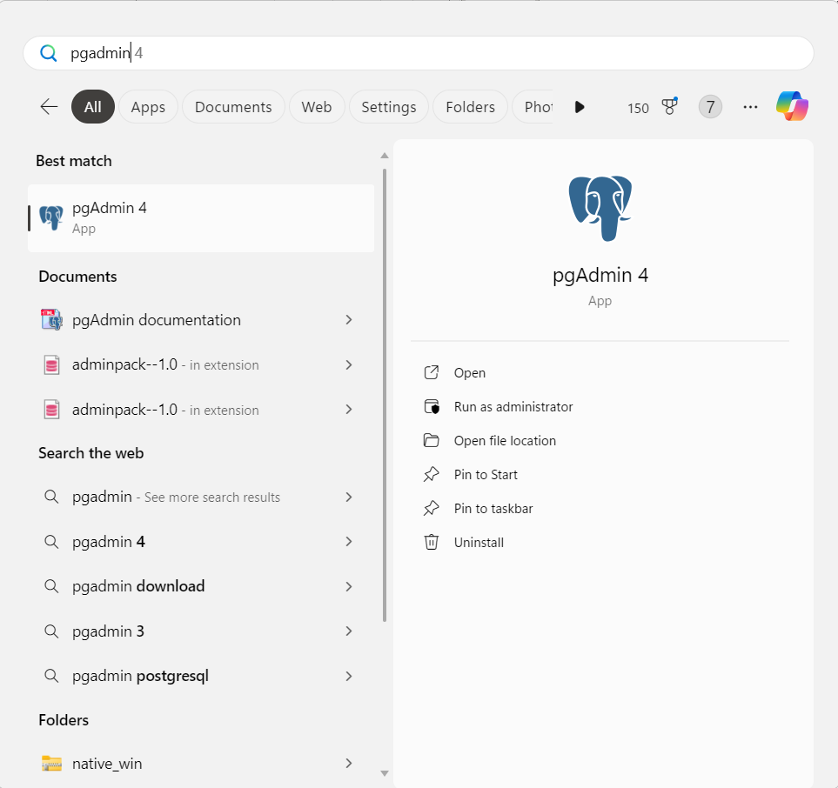

MongoDB
Run MongoDB Compass
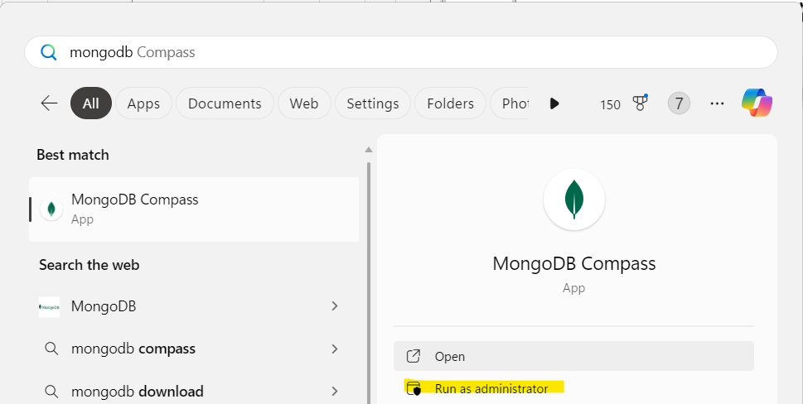

Click on queryopt, then click on Open MongoDB shell
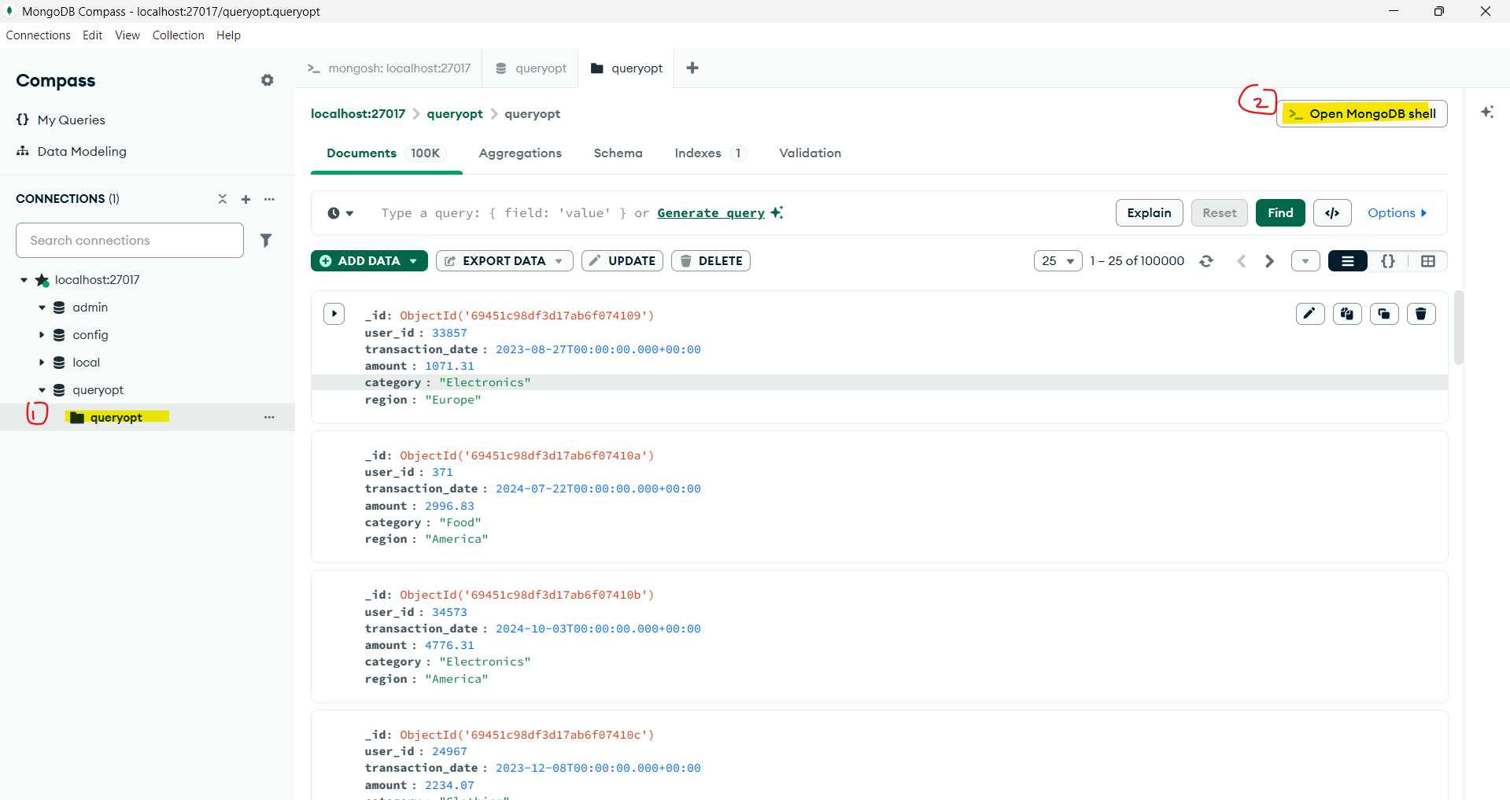

Cassandra
- Open Docker Desktop
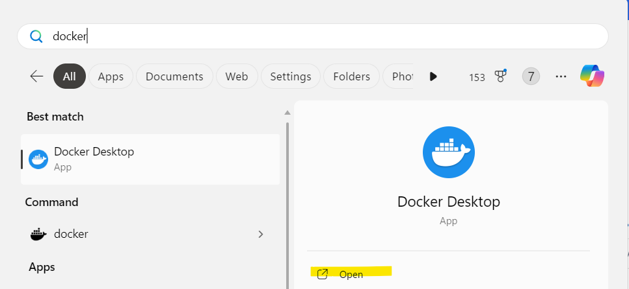

- Click on the play button to start your Cassandra Docker Container
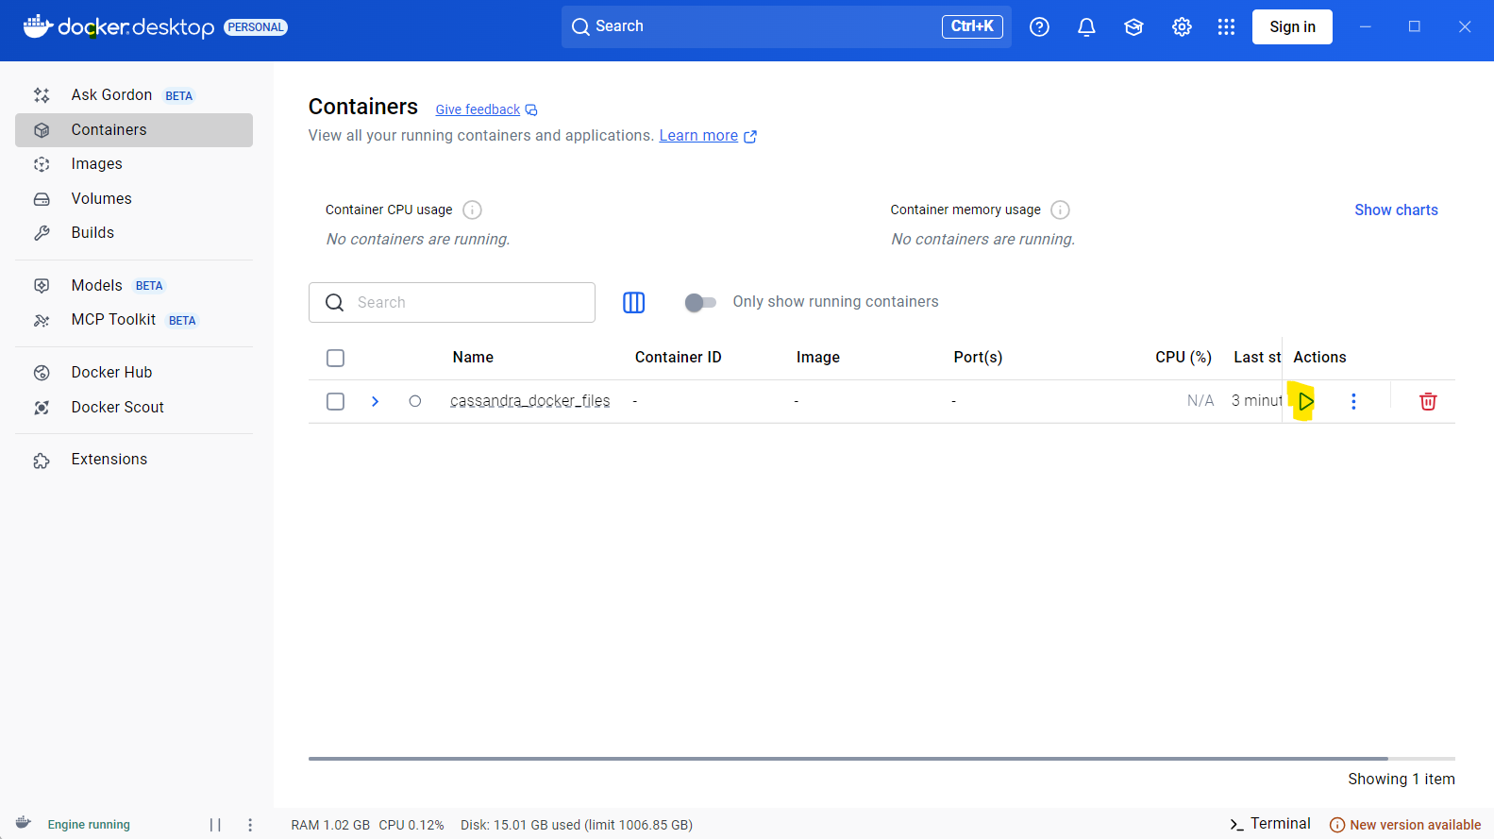

- Open up a terminal, then enter the following commands:
docker exec -it cassandra cqlsh
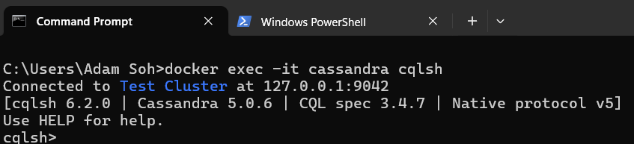

- Enter the code:
use queryopt;
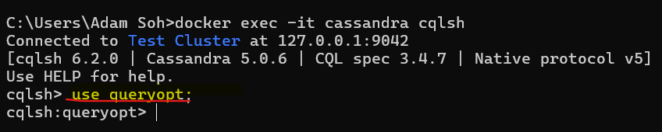
Then you are free to write whatever SQL codes you want.

